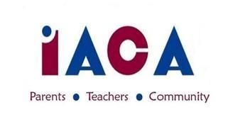

IACA November 2017 MEETING
Wednesday, November 8, 2017
IACS – Library – 7pm; Potluck - 6:30pm

Welcome – Jo Anne
Approval of October Minutes
Completed Events:
Hallowe’en Dances - Faby/Jo Anne
Spectrum Attendees-Parents
Yankee Candle - Annette/Bern
Ongoing/Upcoming Events:
Dining for a Cause
Area-specific Marketing
Quality Night Store
MS Dances - January
Embrace Winter Social
Casino Night/Raffle?

New Business
IACA Cares
IACS Drama’s Trip to NYC
Model UN
SpiritWear - C&C Promos
Open Committee Chairs 2017-2018
Hospitality
8 Grade Moving Up
Round Table
Adjourn

Additional Dates to Keep in Mind
11/14 Dining for a Cause: Owen & Ollies 11/27 Scholastic Book Fair
12/14 ⅚ Quality Night 12/19 ⅞ Quality Night
12/19 HS Exhibition Night

Next IACA Meeting is: Wednesday, January 10, 2018

