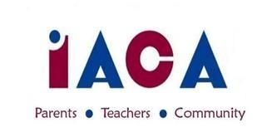

IACA OCTOBER 2017 MEETING
Wednesday, October 11, 2017
IACS – Library – 7pm

Welcome – Jo Anne
Approval of September Minutes
Carry over from last month:
PR info - Michelle
Roberts Rules - Quick Review
Ongoing Events:
Yankee Candle - Annette/Bern
Dining for a Cause
Ask Me Why? Campaign
Upcoming Events:
Pumpkin Run – Heather
Hallowe’en Dances - Faby/Jo Anne
Info Sessions
New Business

Volunteer T-shirts
Fundraising initiatives – Bern
Open Committee Chairs 2017-2018
Hospitality
8 Grade Moving Up
Round Table
Adjourn

Additional Dates to Keep in Mind
10/26 Pumpkin Run (IACS) 10/27 5/6 Halloween Dance
10/28 7/8 Hallowe’en Dance 11/5 HS Info Session
11/14 Dining for a Cause: Owen & Ollies 11/27 Scholastic Book Fair

Next IACA Meeting is: Wednesday, November 8, 2017

