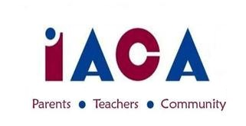

IACA SEPTEMBER 2017 MEETING
Wednesday, September 20, 2017
IACS – Library – 7pm, Potluck Dinner – 6:30

Welcome – Greg
Intro of IACA Board – Jo Anne
Cindi
Sarah
Angela
Bernadette
Michelle
Seema ?
Wrap-up:
Welcome Back Luncheon
MS/HS Ice Cream Socials
Upcoming Events:
Yankee Candle – Annette
Fall Festival – Greg/Heather
Hallowe’en Dances - Faby
Info Sessions – confirm dates
New Business
Ask Me Why? Campaign
Volunteer T-shirts
Fundraising initiatives – Bernadette
PR Plan – Michelle
Memes
Articles
Athletics Wins and Events
Open Committee Chairs 2017-2018
Hospitality
Big Time Social
8 Grade Moving Up
Round Table
Adjourn

Additional Dates to Keep in Mind
9/26 HS Back To School Night 10/10 Dining for a Cause: Tavern In The Square
10/20 Fall Festival (IACS) 10/27 5/6 Halloween Dance
10/28 7/8 Hallowe’en Dance 11/5 HS Info Session

Next IACA Meeting is: Wednesday, October 11, 2017

